**Excel Assignment - 8**

**1. What do you mean by AutoComplete feature in Excel and what are the benefits of using this feature?**

**Autocomplete helps to complete text entries that you start to type in a column of data.**

* Autocomplete eliminates the time that was required to do the task manually.
* It suggests accurate keywords and phrases, ensuring more precise search results.
* It also helps to boost productivity
* It guides you through the search process, offering helpful suggestion along the way.

**2. Explain working with workbooks and working with cells.**

Workbook: Workbook in excel file is a collection of one or more worksheets where the user can organize and analysis the data. User can perform complex calculation and analysis, and also generates insights. Excel can perform budgeting, forecasting and financial modelling task perfectly. It makes data communication effective.

Cell: the rectangular boxes which are present in worksheet are called as cell. Worksheet is made up of thousands of cells. A cell is the interaction of row and a column. An active cell is a cell which is selected that means the one which have bold border. A single cell can be active at a time. Data is stored in tabular form.

**3. What is fill handle in Excel and why do we use it?**

A fill handle is a tool that allows users to quickly copy formula or data down the column or across the row. It makes the task easier and faster for the user if user have to copy the formula to hundred other rows, then it is not possible to copy them one by one so by using fill handle, we can complete the task in seconds. Example: if you have one cell with a value you want to apply to 25 other cells, just click and drag the fill handle and it instantly copies those values over all the cells you select, eliminating time spent manually copying them.

**4. Give some examples of using the fill handle.**

* By using fill handle, you can fill date, numerical values or formulas. By dragging the dot which appears when you select cell.
* Select the cell, set the cursor in the lower right corner of cell then a plus sign will appear
* Drag the fill handle down, when you let go the data is filled automatically

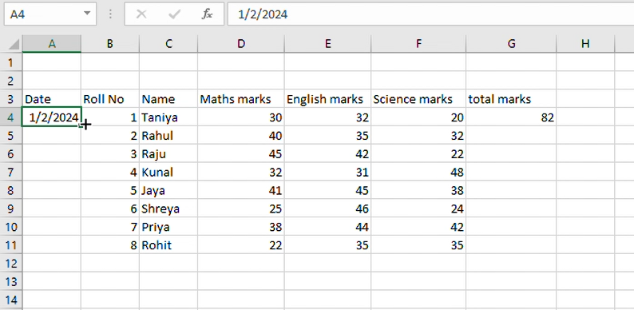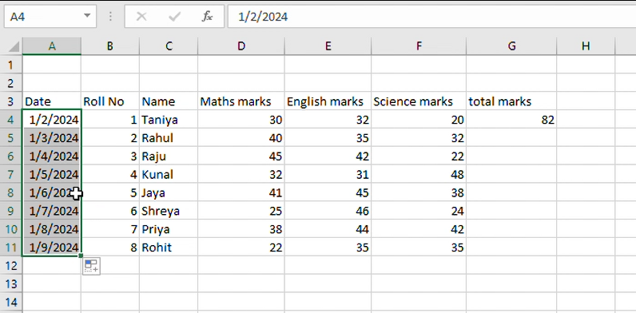

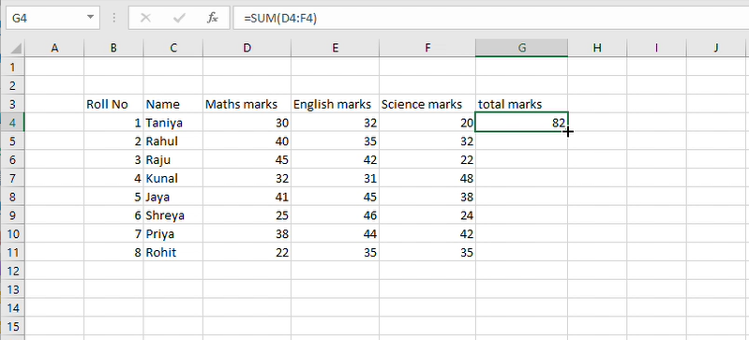

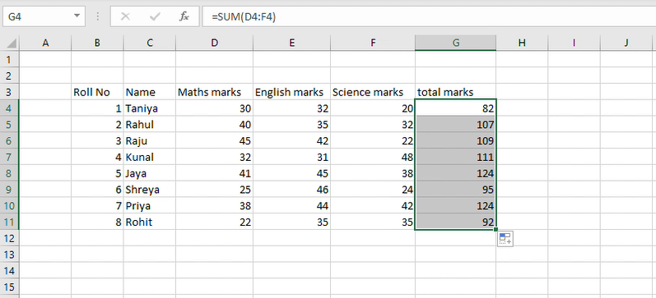

**5. Describe flash fill and what the different ways to access the flash fill are.**

Flash fill automatically fills your data when it sense a pattern.

To access flash fill 1 method:

* Click on file then option
* Click on advance, then click on automatically flash fill ensure the box is checked
* Click ok after that close and restart excel

To access flash fill 2 method: press ctrl + e .

To access flash fill 3 method: click on data tab, in data tool you can see the option of flash fill.

**6. Extract first name and last name from the mail id and then from the address column, extract the city, state, and pin code using the flash fill. Given below is an example of the columns you have to create. Paste the screenshot of what you have created using the flash fill command.**

**Example: Mail Id, Address, First name, Last name, State, City, Pincode**

